COLLEGE CODE : 9623

COLLEGE NAME : Amrita College Of Engineering And Technology

DEPARTMENT : Computer Science and Engineering

STUDENT NMID - B481E74927508BB8B0E4489704478AEC

ROLL NO : 962323104117

DATE : 25.10.2025

Completed the project named as

Phase_05_Technology

PROJECT NAME : Login Authentication System

SUBMITTED BY,

NAME : VARSHINI P

MOBILE NO : 8667593417



**Project Overview**:

* In today’s digital age, online platforms require secure user authentication to protect sensitive information.
* Our Login Authentication System aims to provide a secure, efficient, and user-friendly way for users to register, log in, and manage sessions safely.

This system ensures:

* Passwords are hashed using bcrypt for data security.
* Authentication is handled using JWT (JSON Web Tokens).- Users can reset forgotten passwords through email.
* An admin panel allows administrators to monitor and manage users.-

Security features such as input validation, rate limiting, and account lockout protect against brute-force and injection attacks.

Tech Stack:

* Frontend: React.js (or HTML/CSS/JS prototype)
* Backend: Node.js with Express.js
* Database: MongoDB (Mongoose ORM)
* Styling: Tailwind CSS / Bootstrap
* Version Control & Hosting: Git + GitHub / GitHub Pages

**Project Report :**

The project was developed in multiple phases:

* Phase 1 – Problem Understanding & Requirements We identified the problem of insecure password-based systems and defined user requirements.
* Phase 2 – Solution Design & Architecture Designed the architecture with RESTful APIs, frontend UI, and database schema using MongoDB.
* Phase 3 – Implementation Built the frontend and backend, integrated bcrypt, JWT, and implemented secure routes.
* Phase 4 – Enhancement & Deployment Added Forgot Password, 2FA, Role-Based Dashboard, and deployed the system online.
* Phase 5 – Testing & Final Verification Performed Unit, Integration, and Security Testing to ensure complete system stability

**Screenshots:**

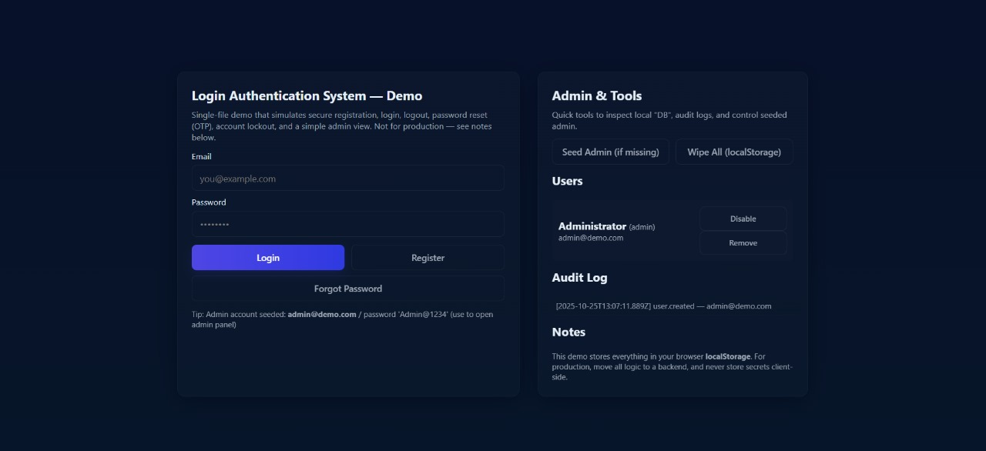

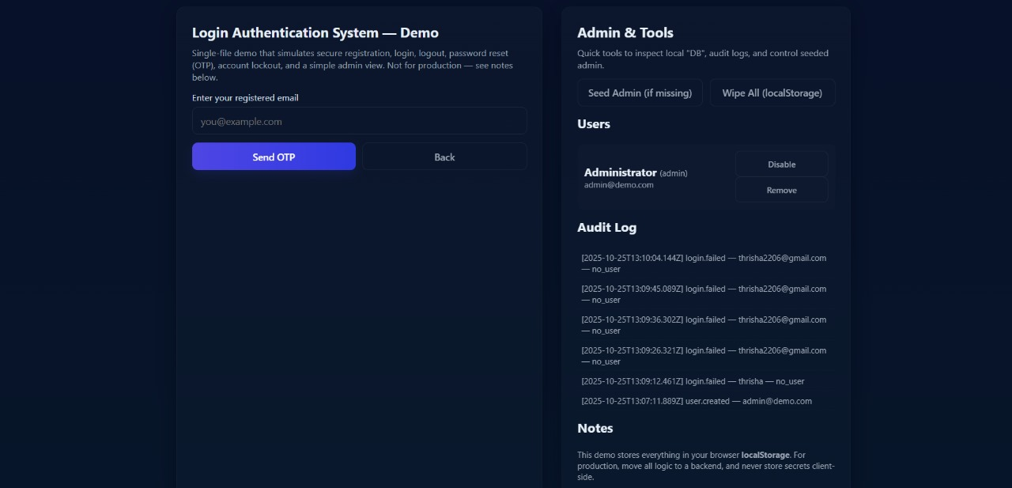

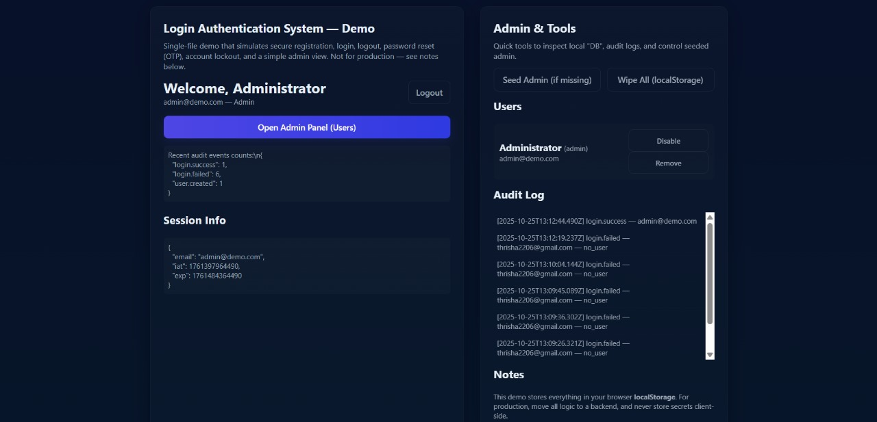

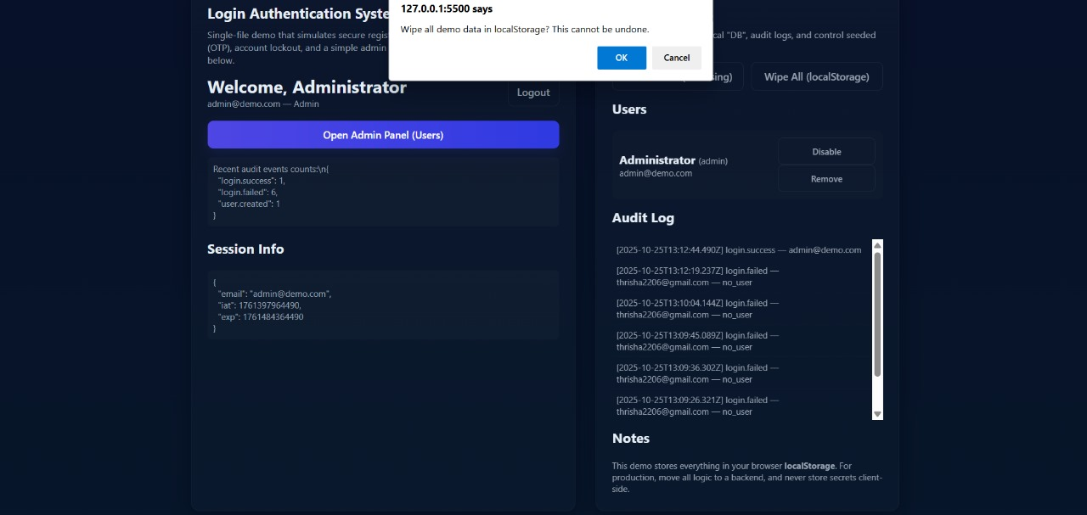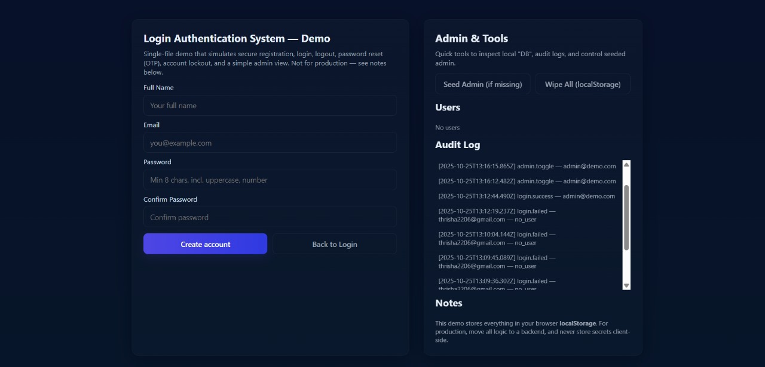

**Challenges & Solutions:**

| **Challenge:** | **Solution Applied:** |
| --- | --- |
| * Difficulty setting up secure password storage | * Implemented bcrypt hashing to safely store passwords |
| * Session expiration & token validation issues | * Switched to JWT-based stateless authentication |
| * Handling repeated failed login attempts | * Added account lockout after 5 invalid attempts |
| * Managing frontend and backend communication | * Used RESTful API architecture and CORS policy setup |
| * UI responsiveness across devices | * Applied Tailwind CSS/Bootstrap for consistent styling |
| * Email service for password reset | * Configured Nodemailer with fallback for testing |
| * Deployment configuration errors | * Resolved with environment variables and GitHub CI/CD |

**Github Link:**

GitHub Repo Link: https://github.com/varshi-1101/Login-Authentication-System.git

Deployed Link**: https://login-authentication-system-rouge.vercel.app/**

“All the project phases (Phase 1 to Phase 5) have been uploaded to the GitHub repository mentioned above.”